**FORWARD AND BACKWARD PROPOGATION**

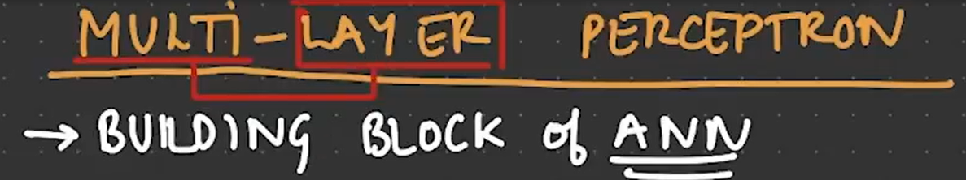

Perceptron is a multi-layered building block of the ANN Model. From the input layer to the output layer, there could be one to many hidden layers can be present this is why it is called hidden layer perceptron.

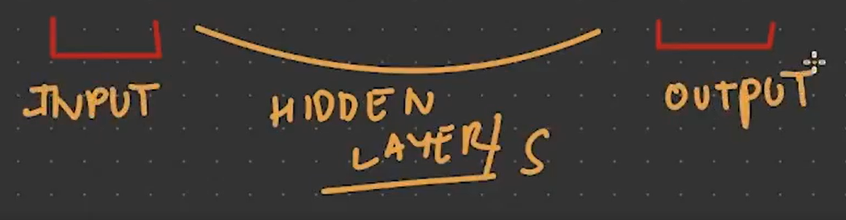

Perceptron means

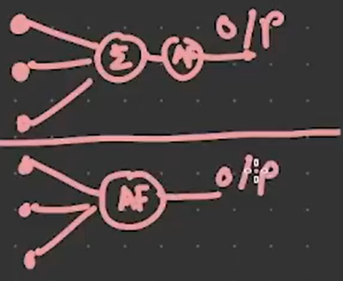

These are called perceptron

Suppose you have 4 inputs such as X1,X2,X3, X4. And there are two hidden layers like below

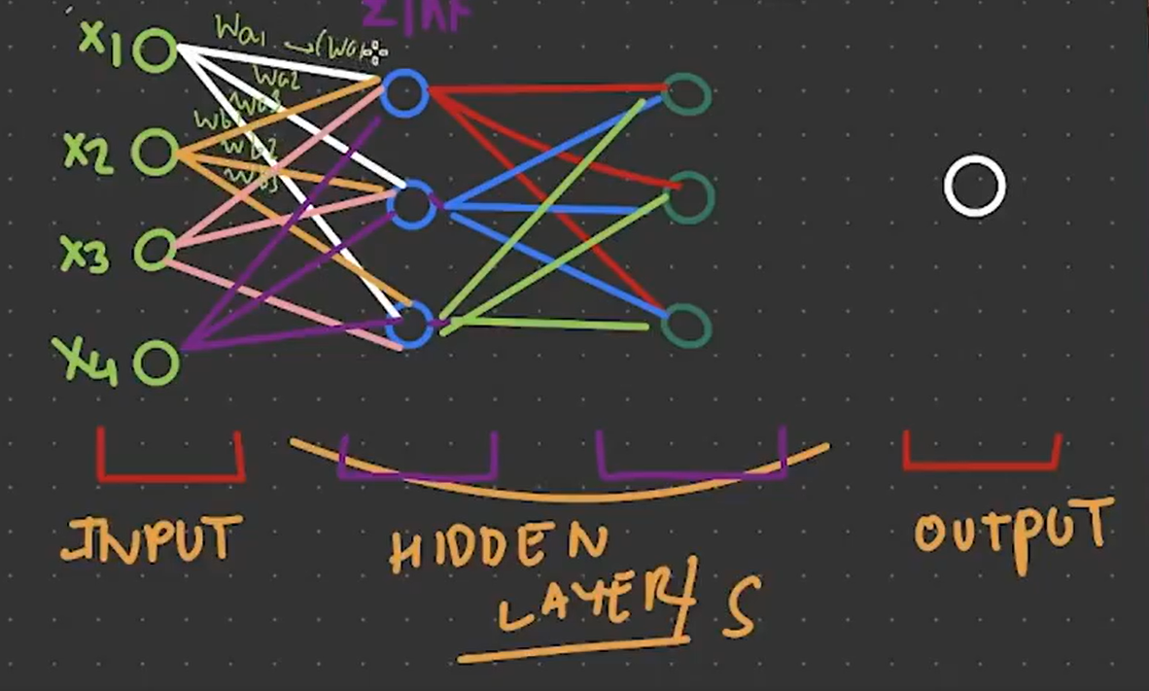

Final output be like

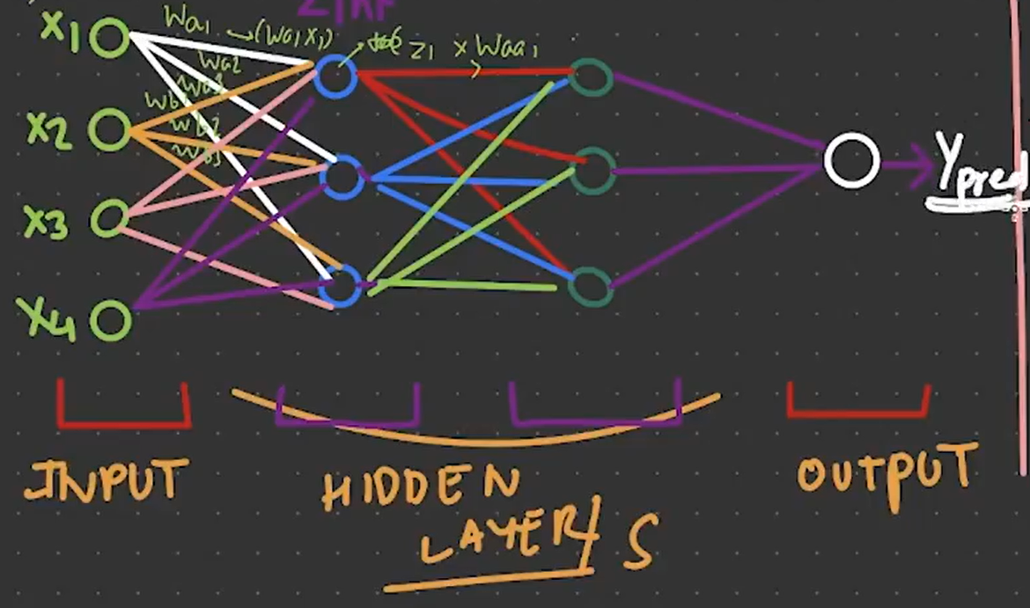

**BACKWORD PROPOGATION**

CHAIN RULE

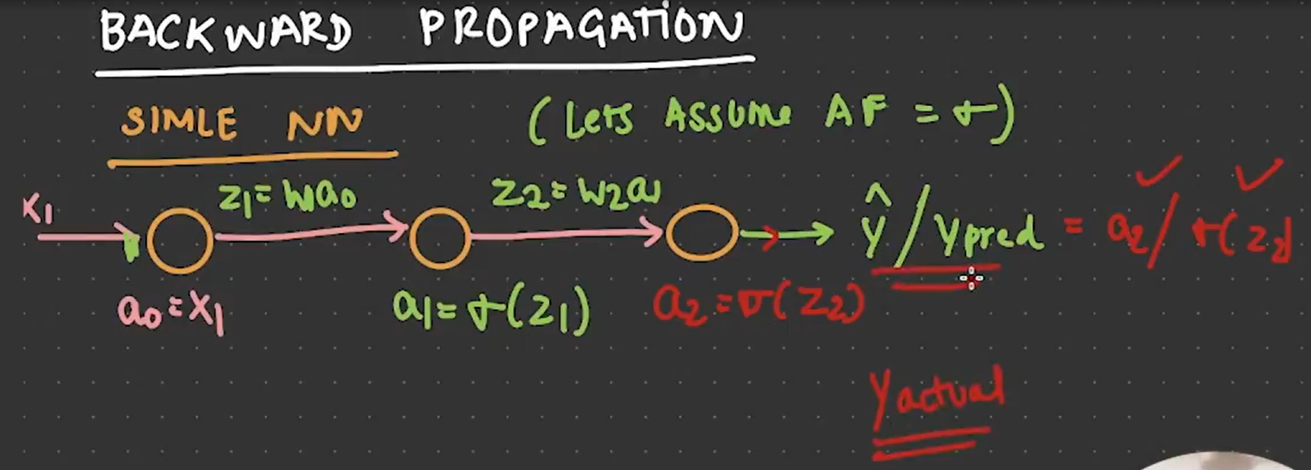

MSE



WEIGHT UPDATE

